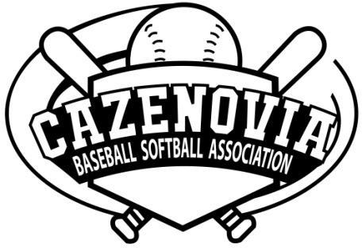 | 2026 SPONSORSHIP OPTIONS
 | Baseball * Softball * T-Ball
We have some of the lowest registration costs for players in comparison to our neighboring leagues. In an effort to keep the fees affordable, we seek donations to help build the program beyond what registration fees will cover.
With your help, we can see our organization grow!
OUR CURRENT GOALS
- A combination baseball/softball pitching machine to complete the batting cages purchased previously (approx. $2,400)

Banner ($300) |  |  | Pitching Machine ($500) | Scoreboard Sponsor ($750)
- Business featured on Website and Facebook/Instagram (with a link to your website, if applicable)  - Business logo on all email communications  - Advertisement on a fence BANNER displayed at Burton Street or Vets Fields (Approx. April-September) |  |  | - Business featured on Website and Facebook/Instagram (with a link to your website, if applicable)  - Business logo on all email communications  - Included in the list of sponsors read out at Community Day when the machine is unveiled  - Advertisement on a batting cage BANNER displayed at Burton Street Fields (Approx. April-September) | - Business featured on Website and Facebook/Instagram (with a link to your website, if applicable)  - Business logo on all email communications  - Business is featured on a sign underneath our scoreboard at Burton Street Fields (3.5 x 2 feet sign)  - Advertisement on a fence BANNER displayed at Burton Street or Vets Fields (Approx. April-September)
2026 Non-Specific Donation
- Business featured on Website and Facebook/Instagram (with a link to your website, if applicable)
- Business logo on all email communications
- This is a great way to support our league in reaching our fundraising goals with any amount you can afford!
Yes! I would like to support Cazenovia Baseball Softball Association
Level |  | Cost |  |  | Make Checks Payable To: Cazenovia Baseball Softball Association  Mail This Form & Check To:  CBSA, PO Box 266, Cazenovia, NY 13066
⌂ Scoreboard Sponsor |  | $750 (1 Available)
⌂ Banner |  | $300
⌂ Pitching Machine Sponsor |  | $500
⌂ Non-specific Donation |  | $
TOTAL
Business/Organization Name |  |  |  |  | Venmo  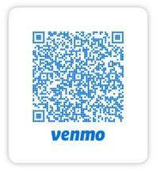  @cazbaseballsoftball
Contact Name
Address
Phone Number
Email

